**Online Test Application - Phase 4**

## **Github Url** - <https://github.com/SathishSubramanian96/OnlineTest_Application.git>

## **Table of contents**

* General info
* Using the application
* Technologies
* Setup

## **General info**

A simple online based application using technologies such as HTML, CSS and JS. The application consists of three modules namely quiz, results and review.

## **Using the application**

User can start the quiz by opening the index.html through chrome browser.

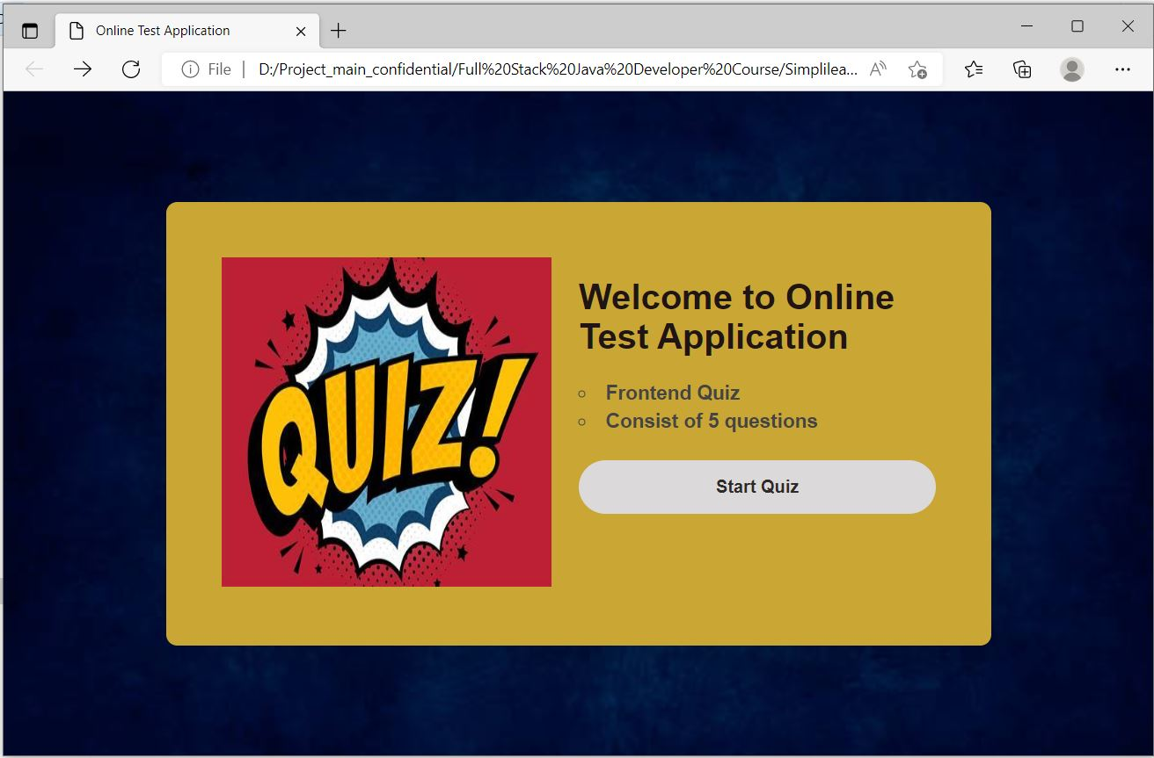

User can attempt the quiz by selecting the correct answer and navigate to the next question using next button.

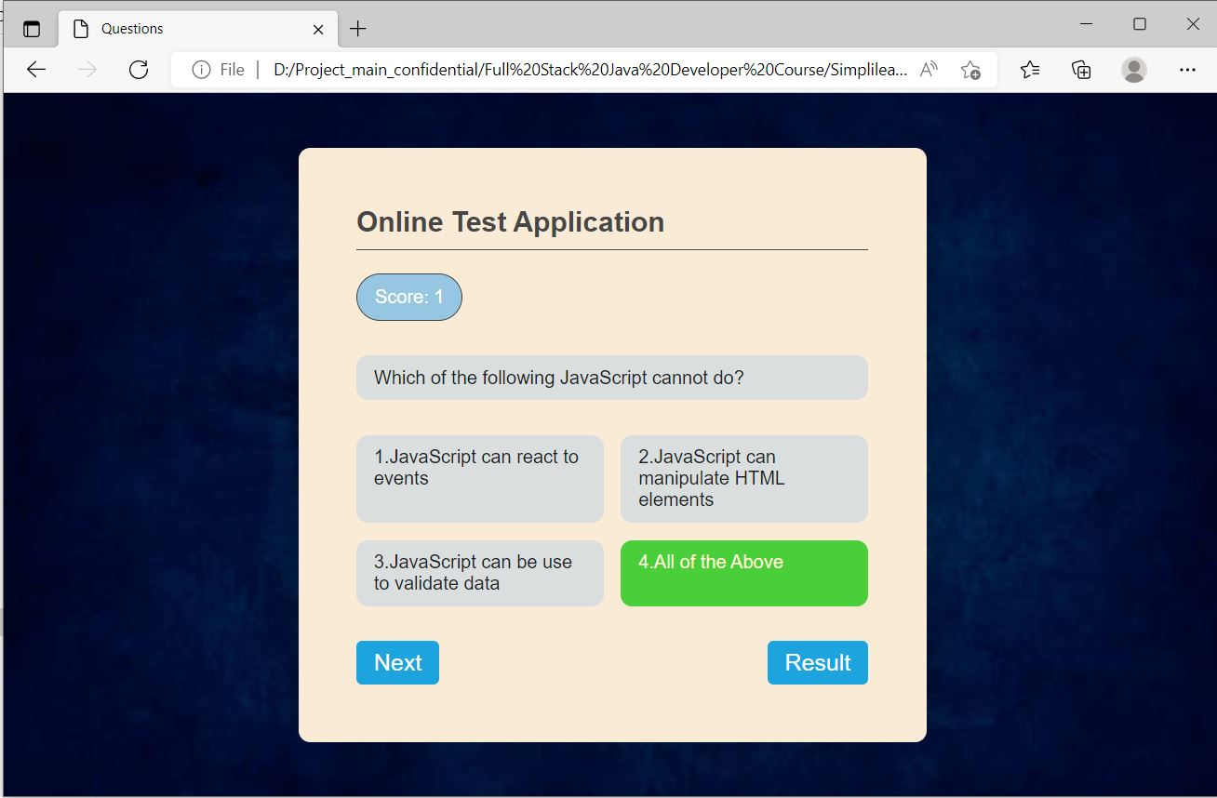

Once the user has attempted all the question will be redirected to result page with results as shown below.

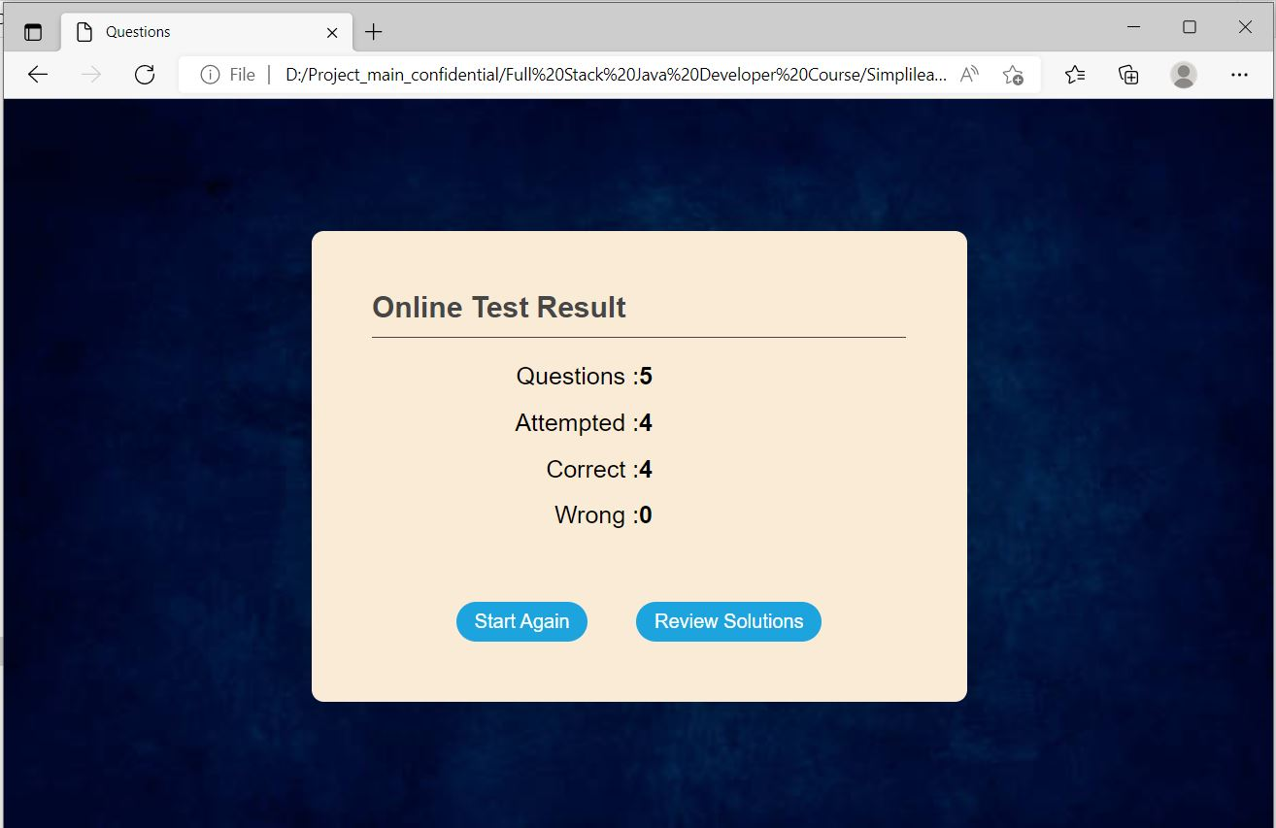

User can also review the answers by selecting the review option as shown below.

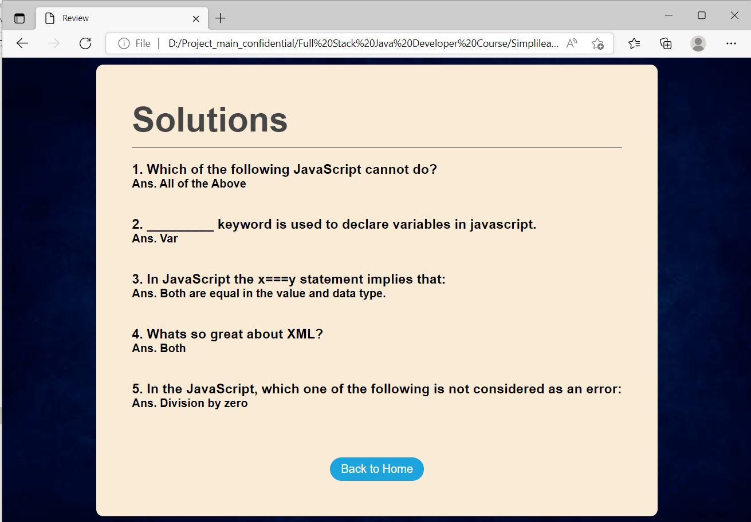

## **Technologies**

Project is created with:

* HTML (Hyper Text Markup Language).
* CSS (Cascade Styling Sheets).
* JS (Java Script).
* Internet Browser(Chrome).

## **Setup**

Open the index.html document via Browsers (Chrome, Microsoft Edge, etc.,).